**Advancements in Cloud Pattern Analysis from Satellite Imagery for Weather Forecasting and Climate Research**

|  |  |  |
| --- | --- | --- |
| **SUBMITTED BY:** | **ADEEL HUSSAIN SHAH** | **ID: 21031305** |

**Introduction**

The objective of this project is to develop a model that can classify cloud patterns in satellite imagery data. This classification will assist researchers in accurately identifying and interpreting cloud patterns for climate change analysis. The collaboration between the machine learning and climate science communities will contribute to the development of predictive algorithms and the discovery of new insights. By conducting more research on cloud patterns and understanding their underlying physics, we can improve future climate models and increase the reliability of climate forecasting. The model focuses on characterizing the mesoscale organization of shallow clouds observed in satellite imagery. These cloud patterns can be classified into four distinct labels: Fish, Sugar, Flower, and Gravel. Each label represents a specific type of cloud formation [1]. Fish patterns exhibit a skeletal or fish-bone-like structure, while Sugar patterns consist of small, compact clouds with low reflectivity. Flower patterns are characterized by circular clumps and represent the strati form elements of clouds. Gravel patterns form from flurry fronts. By comparing cloud patterns with satellite imagery, we can identify important physical differences between different cloud regimes. Satellite images provide a visual representation of individual clouds as well as the spatial patterns generated by similar clouds or sequences of changing cloud forms. While some cloud patterns can be clearly distinguished and utilized in classification techniques and parameter analysis over long periods, others present ambiguity and pose challenges for accurate identification [2]. To address these challenges, we have developed a model capable of identifying common cloud patterns in satellite imagery. This research aims to contribute to our understanding of climate change, as shallow clouds play a crucial role in regulating Earth's climate. However, accurately representing these cloud patterns in climate models remains a complex task that requires ongoing efforts.

**Purpose of Dataset Understanding Clouds From Satellite Images.**

The task of "Understanding Clouds from Satellite Images" pertains to the analysis and classification of various cloud formations observed in satellite imagery. It falls within the domains of computer vision and remote sensing. The objective is to create machine learning or deep learning models capable of accurately recognizing and classifying various cloud patterns, including cumulus clouds, cirrus clouds, stratus clouds, and other types, using satellite imagery [3]. The objective is to obtain knowledge about cloud dynamics, weather patterns, and atmospheric processes, with potential applications in weather forecasting, climate research, and environmental monitoring.

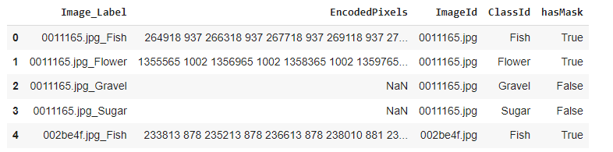**Exploratory Analysis** The dataset involved assessing its composition, dimensionality, and structure by examining sample sizes, variable counts, and missing values. Exploratory visualizations, such as histograms and scatter plots, were employed to analyze data distribution and relationships among cloud types, image attributes, and metadata. This exploratory analysis yielded valuable insights into the dataset's characteristics and potential challenges, laying a robust groundwork for advanced analytics. Fig. 1 illustrates the process of reading a CSV file into a data frame and displaying the initial rows to facilitate inspection and analysis. Additionally, The findings from this exploratory study guided subsequent tasks and analyses, fostering a comprehensive understanding of the dataset and facilitating further analysis and modeling based on a solid knowledge foundation.

Fig. 1 illustrates the process of reading a dataset CSV file

**Presented Bar Graph**

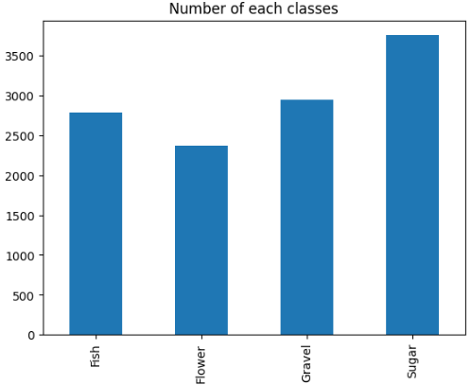The presented bar graph Shown in Fig.2. Provides an overview of the occurrence of distinct cloud patterns in the dataset, denoted by the labels Fish, Flower, Gravel, and Sugar. Each label represents a unique type of cloud pattern. The vertical axis of the graph indicates the frequency or count of instances for each cloud pattern, visually depicted by the height of the corresponding bar. Through the examination of this bar graph, a comparative analysis of the relative frequencies of Fish, Flower, Gravel, and Sugar patterns can be performed, offering valuable insights into the distribution and prevalence of these cloud types within the dataset. This information plays a pivotal role in comprehending the composition and characteristics of the cloud patterns captured in the satellite imagery data.

Fig.1 Shows a Bar Graph of the dataset

**Nadam Optimizer**

NADAM is an optimization algorithm that integrates adaptive learning rates with Nesterov momentum. It adjusts the learning rate based on past gradients and uses direction-aware momentum for faster convergence. Widely employed in image classification, object detection, and natural language processing, Nadam provides efficient optimization for deep learning models [4].

**Sigmoid Activation Function**

The sigmoid activation function is commonly used as a non-linear activation function in neural networks, particularly for binary classification tasks. It transforms the input value into a range between 0 and 1, allowing it to be interpreted as a probability or confidence score. The sigmoid function compresses the input into a sigmoidal curve, aiding in probability estimation and decision-making. As a result, it is a valuable choice for assessing the likelihood of an instance belonging to a particular class in binary classification tasks [5].

1. **Model Vanilla U-Net**

The Vanilla U-Net model is a well-known architecture used for semantic segmentation in computer vision. It is based on the U-Net architecture, which excels at segmenting images on a pixel level. The model follows an encoder-decoder structure, where the encoder captures and encodes the contextual information of the input image. The decoder, on the other hand, reconstructs the segmented output by gradually upsampling the features obtained from the encoder. One of the key features of the U-Net architecture is the inclusion of skip connections, which allow the model to combine low-level and high-level features for more accurate segmentation. The Vanilla U-Net model has been extensively employed in various fields like medical image segmentation, object detection, and scene understanding. Due to its simplicity and effectiveness, it is a popular choice for many segmentation tasks [6]. Researchers and practitioners often modify the Vanilla U-Net model by incorporating additional layers or using different optimization techniques to enhance its performance for specific applications.

**Model Performance and their Prediction** 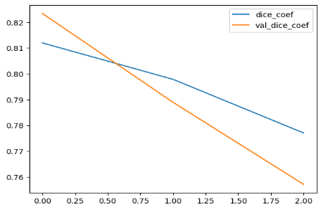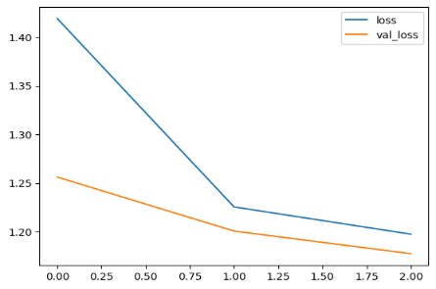

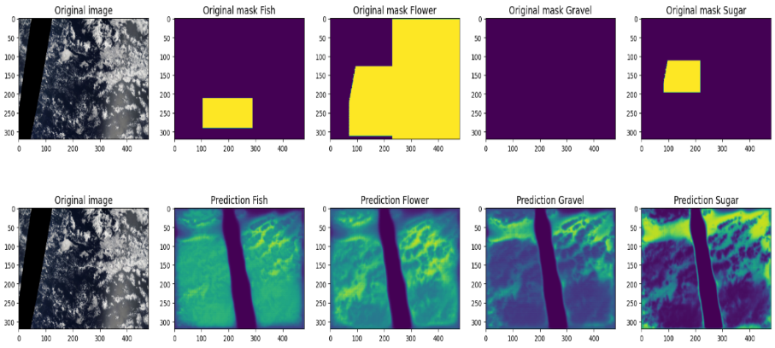

1. **Model Vanilla U-Net Crop**

The Vanilla U-Net Crop model is a modified version of the Vanilla U-Net architecture that integrates cropping operations. This variant aims to enhance semantic segmentation performance by focusing on smaller regions of interest in the input images. By incorporating cropping during skip connections, the model can extract significant features from specific areas. It is particularly valuable in medical image analysis and other tasks that require precise segmentation within localized regions [7]. The Vanilla U-Net Crop model can be customized with additional layers or architectural adjustments to further optimize its performance for specific applications.

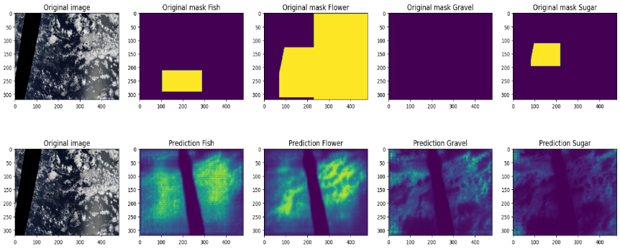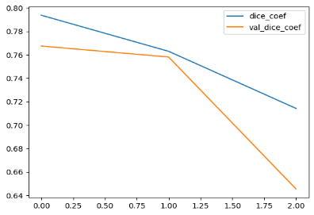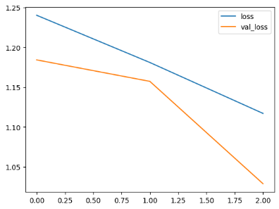 **Model Performance and Their Prediction**

1. **Model Vanilla U-Net Downscale**

The Vanilla U-Net Downscale model is derived from the Vanilla U-Net architecture and introduces downsampling operations to handle high-resolution images effectively while ensuring precise segmentation. By reducing the spatial dimensions during encoding, it improves computational efficiency. This model is particularly valuable in applications such as satellite imagery and medical imaging, where high-resolution input is vital [8]. It can be further personalized and optimized by incorporating extra layers or modifications to meet specific segmentation needs.

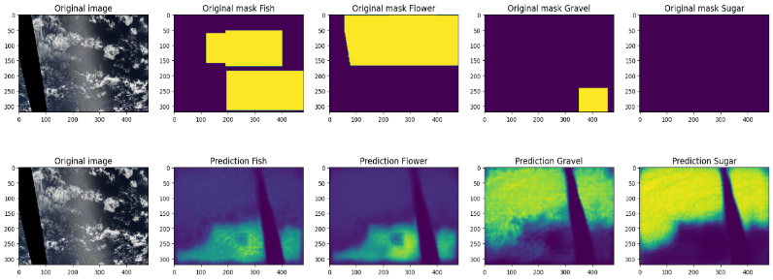 **Model Prediction**

1. **Model Vanilla U-Net Downscale Crop**

The Vanilla U-Net Downscale Crop model merges down sampling and cropping techniques to efficiently process high-resolution images while emphasizing specific regions of interest. It decreases spatial dimensions during encoding for computational efficiency and incorporates cropping within skip connections to extract features from targeted areas. This model is particularly suitable for tasks demanding accurate localization and segmentation within intricate images, such as medical analysis or remote sensing. Customization and optimization options include adding extra layers or implementing modifications to enhance performance [9].

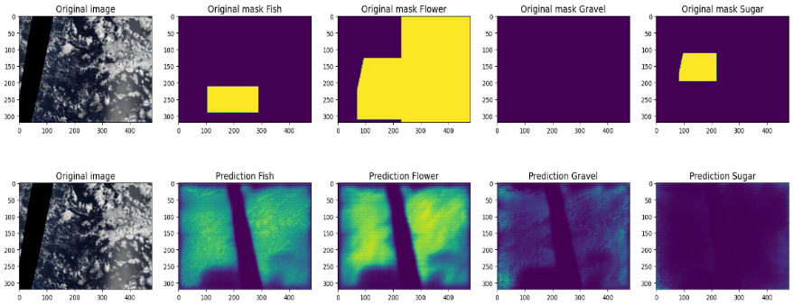 **Model Prediction**

**Critical Analysis of My Assignment**

Although the four models presented in your assignment offer different adaptations of the Vanilla U-Net approach, they appear to lack distinct innovations or solutions for addressing the challenges of cloud classification. The selected methodologies raise valid concerns regarding the potential loss of context, detail, and compromised accuracy. To enhance the analysis, it is recommended to explore novel techniques or modifications that effectively tackle these limitations and improve the models' performance and robustness.

**Future Work**

Future work of our assignment in involves improving existing models, extending their classification abilities to cover multiple cloud types, diversifying the dataset, investigating transfer learning, developing interpretability and visualization methods, integrating models with climate models, and enabling real-time cloud monitoring. These advancements aim to enhance model performance, enable comprehensive cloud formation analysis, improve generalization, and deepen our understanding of cloud dynamics and their influence on weather patterns and climate change. Ultimately, these endeavors will contribute to advancements in weather forecasting, climate research, and environmental monitoring.

**Google colab Link:**

[**https://colab.research.google.com/drive/1qJV9jZSxgFvu6pIGmW9GH263NDT_Bi8X?usp=sharing**](https://colab.research.google.com/drive/1qJV9jZSxgFvu6pIGmW9GH263NDT_Bi8X?usp=sharing)

**GitHub LINK:**

[**https://github.com/AdeelHusaain/Assignment-on-Dataset**](https://github.com/AdeelHusaain/Assignment-on-Dataset)

**References:**

1. Varma, T., Bane, A., Bundge, S., & Thomas, B. CLOUD CLASSIFICATION USING DEEP LEARNING.
2. Ahmed, T., & Sabab, N. H. N. (2022). Classification and understanding of cloud structures via satellite images with EfficientUNet. *SN Computer Science*, *3*, 1-11.
3. <https://www.kaggle.com/competitions/understanding_cloud_organization/data>
4. Tato, A., & Nkambou, R. (2018). Improving adam optimizer.
5. Pratiwi, H., Windarto, A. P., Susliansyah, S., Aria, R. R., Susilowati, S., Rahayu, L. K., ... & Rahadjeng, I. R. (2020, February). Sigmoid activation function in selecting the best model of artificial neural networks. In *Journal of Physics: Conference Series* (Vol. 1471, No. 1, p. 012010). IOP Publishing.
6. Hammer, B., Melnik, A., Velioglu, R., Vieth, M., & Schilling, M. (2022, July). A graph-based U-net model for predicting traffic in unseen cities. In *2022 International Joint Conference on Neural Networks (IJCNN)* (pp. 1-8). IEEE.
7. Ye, J., Wang, H., Huang, Z., Deng, Z., Su, Y., Tu, C., ... & He, J. (2022). Exploring Vanilla U-Net for Lesion Segmentation from Whole-body FDG-PET/CT Scans. *arXiv preprint arXiv:2210.07490*.
8. Wang, T., Xiong, J., Xu, X., Jiang, M., Yuan, H., Huang, M., ... & Shi, Y. (2019). Msu-net: Multiscale statistical u-net for real-time 3d cardiac mri video segmentation. In *Medical Image Computing and Computer Assisted Intervention–MICCAI 2019: 22nd International Conference, Shenzhen, China, October 13–17, 2019, Proceedings, Part II 22* (pp. 614-622). Springer International Publishing.
9. Fan, J., Chen, D., Wen, J., Sun, Y., & Gomes, C. P. (2022). Monitoring Vegetation From Space at Extremely Fine Resolutions via Coarsely-Supervised Smooth U-Net. *arXiv preprint arXiv:2207.08022*.